

Basic App Flow

Basic App Flow
To start doing cases
- Open the DocStat App and click SIGN IN
- Enter your registered mobile number and the OTP. You will then be logged in
- Post login, click on “GO ONLINE’ to start receiving cases
- On DocStat, cases are assigned one after the other. Whenever you wish to stop doing cases; ensure you click GO OFFLINE in the app before closing it. Note - Do not minimize the app without going offline

Types of cases to expect on DocStat for consultation -
The following types of cases will be assigned on DocStat -
- Cases with no prescription attached but Prescription required medicines ordered
- Prescription uploaded but the image is unclear/blurred
- Medicines ordered which are not included in the prescription attached
- Invalid prescription -
- Date missing
- Patient Name missing
- RMP details missing (name and degree)
- Duration expired (Old prescription)
The reason for consultation is clearly mentioned in the first page of the case.

RMP Process
Once a case is assigned to a RMP, the RMP must check the medicine list and the attached prescriptions for reference.
Initiate a consultation call and discuss the patient’s health details to prescribe the medicines.

To ensure a complete consultation, the RMP must confirm the following details on every call -
- Patient Name
- Patient Age
- Diagnosis (medical condition for which the medicines have been added)
- Last RMP visit
- Any known drug allergies
- Any additional details (current symptoms / blood test details, etc)
- Medical advice - Dosage details (once/twice a day; before/after meal, etc)

Based on the above details; the following data to be updated in the app -
- Patient Name
- Age
- Gender
- Diagnosis
- ADD medicines
- Dosage and Duration for each medicine

App Navigation -
Once a case is assigned; it will be seen as “New Case” on your home page.
Click “Click to View details”

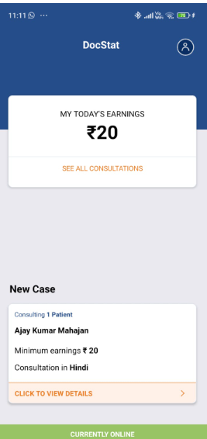

You will see the medicine list and the case attachments here.
Click “CALL” on the bottom right.

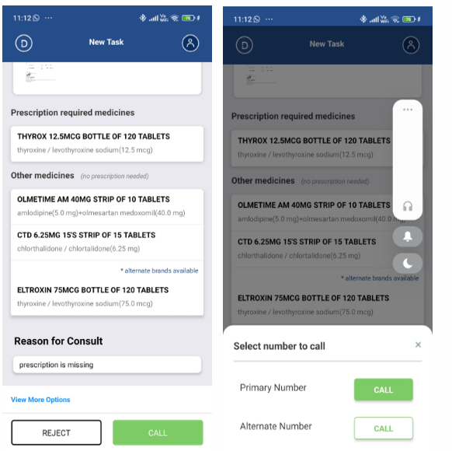

Hold and Reschedule options
If the call goes unanswered or if the number is busy; put the case on Hold.
The hold option is available on the left side of the “Prescribe Now” button.
If the call is answered but the customer cannot speak and wants to be connected later; you must reschedule the case. To Reschedule a case, disconnect the call and click on the “Reschedule icon”. This option is available next to the Hold icon.
Do NOT Reject such cases.

In the image below -
From Left to Right -
“Reschedule” —> “HOLD” —> “PRESCRIBE NOW”

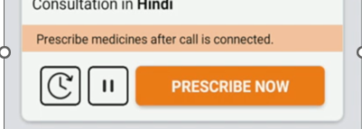

Once the call is connected; start with the consultation and click “Prescribe Now”.
This will lead you to the next page where the Patient name, Age, Gender and Diagnosis must be updated.

Based on the above details; the following data to be updated in the app -
- Patient Name
- Age
- Gender
- Diagnosis
- ADD medicines
- Dosage and Duration for each medicine

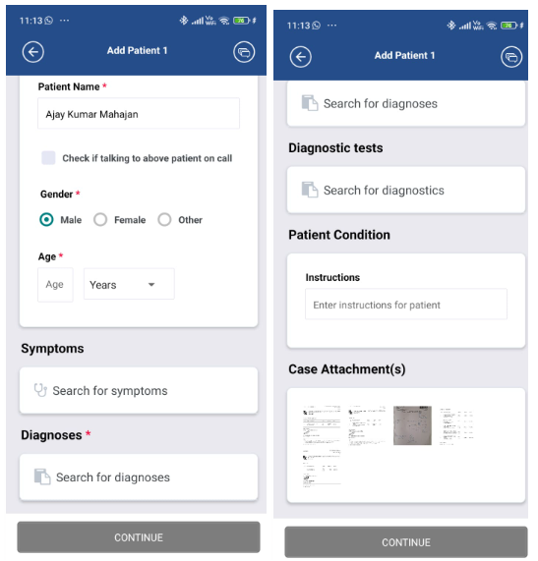

Here, there is also an option to prescribe Diagnostic Tests for the patient.
Start typing the Test name in the ‘text field’ and click DONE.
Do suggest Diagnostic Tests to patients as per their medical condition.
Inform them that you are prescribing a few tests and they can book the same from PharmEasy.
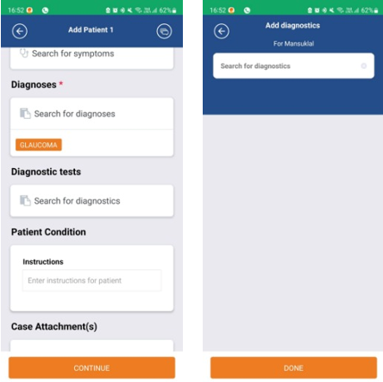

Next, click CONTINUE at the bottom of the page.

You will see the list of medicines with an ADD option next to each medicine.
Please note you only have to consult and ADD the medicines listed in the “Prescription Required Medicines List”.
DO NOT ADD medicines/products from the “Others list” as they include medicines for which a valid prescription is already available or they are OTC products.
If you need to add any additional medicine, click ADD MORE and start typing the name of the medicine. You will get relevant suggestions in the dropdown and you may then click on the medicine to be added.
Click ADD for the medicines to be prescribed.

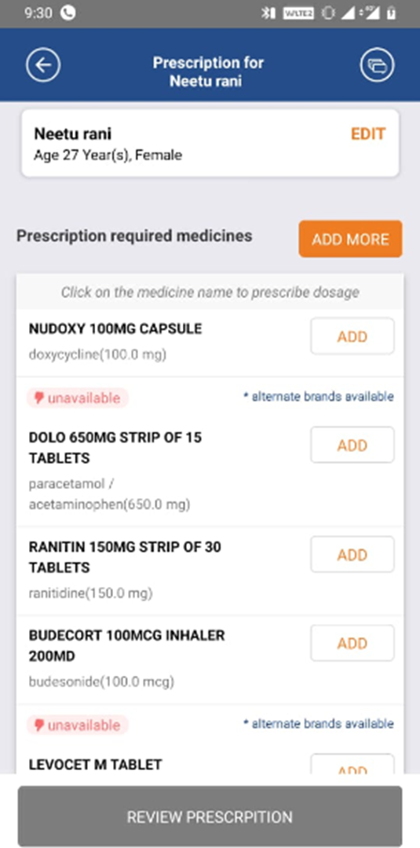

Then, click on each medicine to update its dosage and duration.

Please find below the Dosage page.

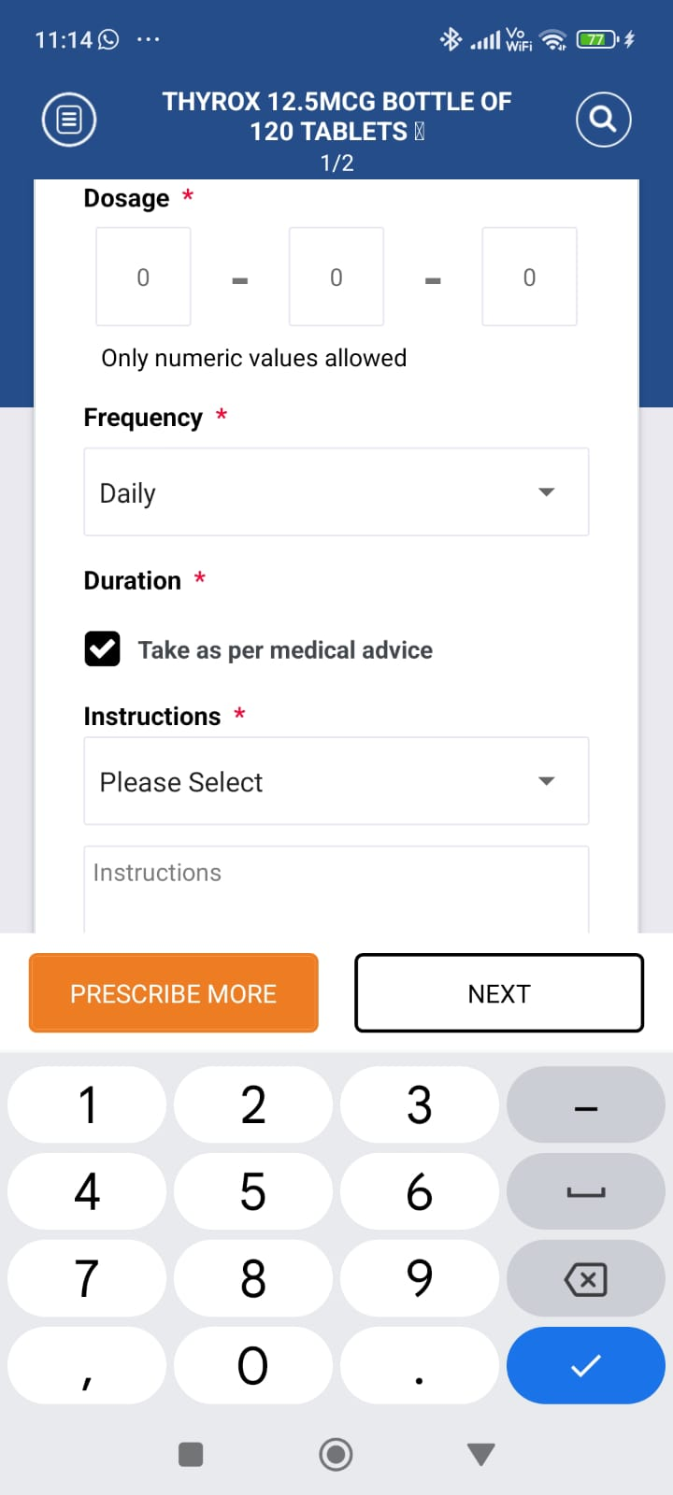

Here, the dosage must be updated along with the Frequency and Duration for that medicine.
The medicine name is mentioned on the top of this page.

Ensure you refer to the patient’s original prescription while updating these details.
As per your consultation call; if you wish to alter the dosage details; discuss the same about this with the patient on the call.

The last dropdown is to update instructions. It includes 3 options -
Before Meal
After Meal
Others - to be selected for cream / ointment / shampoo / eye drops / nasal spray, etc.

Click on “Review Prescription” at the bottom of the page.
Here, you will see a preview of the prescription you have generated.
Verify the details and click on EDIT if something needs to be updated.
Once all details have been added, click on SUBMIT AND CLOSE CASE. This case will be processed and a new case will be assigned to you.
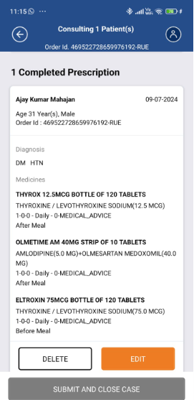

Cases with multiple patients -
In some cases, the medicines listed might be for more than 1 patient. Here, you will generate prescriptions for every patient one by one. Consultation must be done patient wise and medicines must also be prescribed patient wise.
On the app, click Prescribe Now and enter the first patient’s details - Name, age, gender, Diagnosis.
While Adding medicines; click ADD only for the medicines of the first patient from the Prescription Required list.
Update the dosage and duration for these medicines and click “Review Prescription”.
Here, click the “Add New Prescription” option available at the top of the page.
Enter the second patient’s details - Name, age, gender, Diagnosis.
While Adding medicines, click ADD only for the medicines of the second patient from the Prescription Required List. Update the dosage and duration of these medicines and click “Review Prescription”.
On the “Review Prescription” page, you will see the preview of both the patients. Verify all details and click “SUBMIT case.”

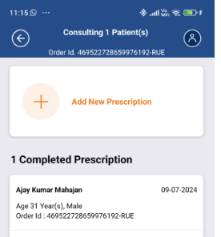

Case Rejection -
Please find below the various scenarios where a RMP can Reject a case assigned to him/her.
To Reject a case; click the REJECT option on the bottom left side of the screen.
You will then see 5 options -
- Cannot Prescribe Medicine Over Call
This rejection must be selected when the medicines in the case cannot be prescribed by the RMP due to various reasons. These include -
- Medicines ordered for animals
- Medicines ordered for a retail shop
- Medicines not suitable to be prescribed over teleconsultation, and without any recent past prescription eg oral contraceptive pills
- If the RMP suspects the patient is abusing or misusing the medicine Drugs regulated in Schedule X
- Drugs regulated in Schedule X of the Drug and Cosmetic Act and Rules or any Narcotic and/or Psychotropic substance listed in the Narcotic Drugs and Psychotropic should never be prescribed on teleconsultation.

- Refused Consultation
This rejection reason is valid only after a complete call. This rejection must be selected when the customer on the call refuses to provide details for consultation or does not want the ordered medicines. The various scenarios for this rejection includes -
- Customer says Ordered by mistake
- Customer asks to cancel the order
- Customer says medicines are not required now
- Customer unaware of any medicine order placed
- Customer refusing consultation stating original prescription has already been uploaded
- Customer refusing consultation stating they do not wish to discuss patient details

- Already Bought Medicines
This rejection is selected when the customer says that they have already purchased the medicines from another source.

- Already placed a new order with a Valid Rx
This rejection is selected when the customer informs you that a different order for the same set of medicines is already in process and hence, this order is now not required. This happens when customers place duplicate orders.

- Reassign to Admin
The last rejection option is Reassign to Admin. Once this reason is selected, you get a text box to add notes. The scenarios for which the case is reassigned to admin include -
- When the customer’s number is switched off / not reachable / incoming service not available / Invalid
- When the customer is not cooperating / rude
- Language Barrier
- When the Prescription has a medicine tagged as “Do not prescribe over teleconsultation” - exercise caution while handling such cases. Reject only if all meds are marked as “Do not prescribe over teleconsultation”. If there are products/medicines in the prescribed or other list - please reassign to the admin with case notes

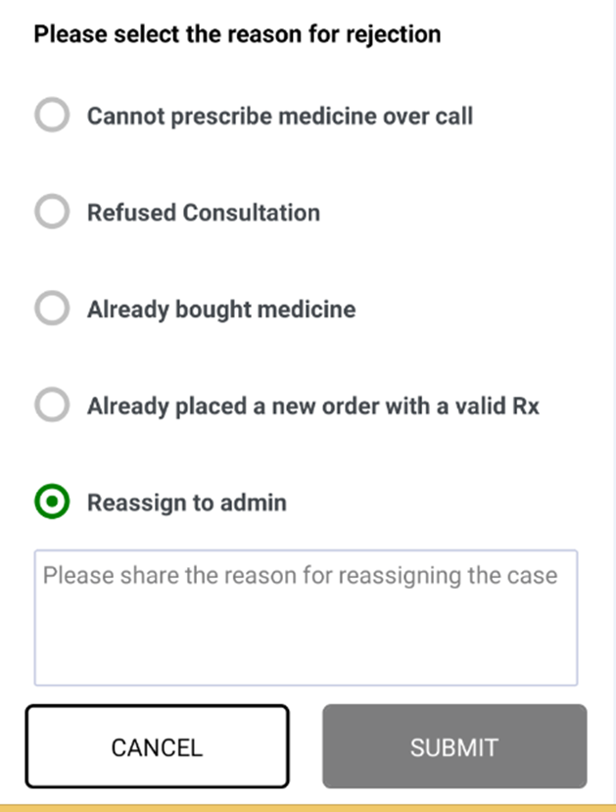

Prescribing Alternatives
There are cases when the medicine ordered by the customer is in limited stock which can impact the delivery time or there is a cheaper alternative available. We encourage doctors to suggest alternatives to the patient in those cases to help us deliver the required medicines to the patient as soon as possible or to make the medicines a little more pocket friendly to the patients
While adding medicines; the app suggests alternatives for certain medicines which are limited in stock. These medicines are tagged ‘unavailable’. Once you click ADD - you will see the list of substitutes. These substitutes have the same salt/composition and dosage form (you can check the molecule name below the medicine name), however only the brand and price is different. The price is also visible in the app with the percentage difference for you to give clarity to the patient.
Before a substitute is prescribed in the order, a clear consent must be taken on the call from the customer. Also, the RMP must inform the name of the substitute and assure that the delivery is guaranteed.
Click ADD
Inform about the alternative and take consent.
If the customer agrees, select the alternative and click PRESCRIBE NEW.
If the customer denies, click KEEP ORIGINAL.

App image that shows alternatives for medicines marked ‘Unavailable’

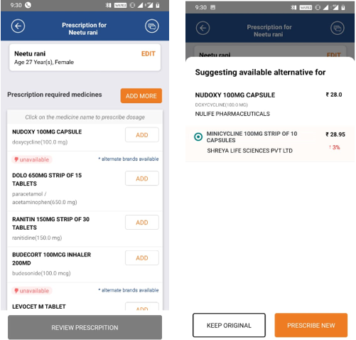

App image showing alternatives for Available medicine.

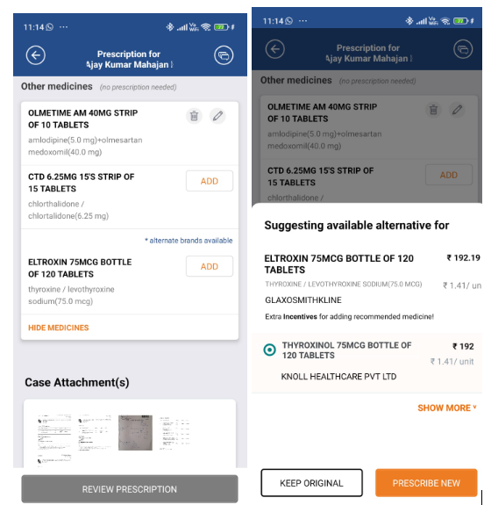

Price Based
Goal is to provide affordable medicines to patients. Hence the RMP can suggest alternatives that cost less , if the actual brand patient is asking is out of stock or has limited availability

Handling Priority Cases
While doing consultations; a few cases will be tagged as “EXPRESS DELIVERY”.
These orders have been tagged as the customer has opted for an Express delivery service on PharmEasy.
Please note - It is mandatory to make 2 calls for all express orders. You can put the order on hold if the customer does not answer after 2 calls.
If the call is not connected on the first attempt, ensure that you Redial 1 more times and then put the case on HOLD.
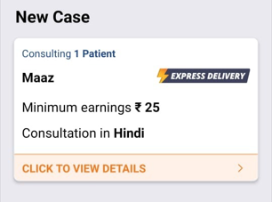

Once the case is submitted, a prescription is generated which includes the following details -
- Order ID
- Name of the RMP
- RMP Degree
- RMP’s Registration number
- RMP Signature
- Date
- Patient Name / Age / Gender
- Medicines Added along with their dosage and duration
- Note at the end of the Prescription –

